**JAYPEE INSTITUTE OF INFORMATION TECHNOLOGY NOIDA - 62**

**DATABASE AND WEB DEVELOPMENT PROJECT SYNOPSIS**

**SEMESTER-3**

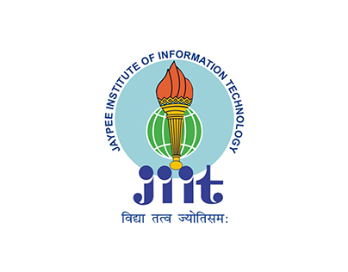

UNDER SUPERVISION OF:

**DR. INDU CHAWLA**

**ASSISTANT PROFESSOR (SENIOR GRADE)**

SUBMITTED BY: -

ADITI JAIN (20103273)

TANUPRIYA PATHAK

(20103288)

BATCH: -B10

BRANCH: -CSE

LIT.HUB

“Getting high on knowledge”

Knowledge is having the right answer and Intelligence is asking the right question.

Turnt.hub brings a platform in support of freshly emerging computer science undergraduates with their uplifted spirits to conquer the tech world as well as our most talented and experienced engineers or to be Engineers from all over the tech depths to extend a helping hand towards our newbies.

Finding a mentor in initial days of college is one of the most difficult tasks to be executed by a freshly entered graduate. Students face lack of awareness on how to have a firm grip of all the responsibilities ranging from getting used to college’s ecosystem to upgrading skillsets for a smooth transition into the tech world.

Situations got worse as the world was hit by a seemingly never-ending pandemic and forced student to take this journey in action from their very own homes depriving them from the needed exposure.

As our vision says “getting high on knowledge”, our virtual ecosystem

brings this facility at everyone’s doorstep.

DBMS STRUCTURE:

Here contributors will have their own profile where they can upload their projects on the technologies they have ventured, they can also share their experiences from initial years of their engineering via blogs posts and even explanatory videos.

Whereas our users can access these projects blogs and through our interface.

ER DIAGRAM:

